SOURCE OF FUNDS / WEALTH DECLARATION

In order to comply with our regulatory obligations we are obliged to obtain information about our customer’s source of funds and source of wealth. In certain circumstances we will also require documentary evidence (see Appendix 1). Please avoid generic responses such as ”employment” or ”inheritance.”

Full Name: | Click here to enter text.
Registered Address: | Click here to enter text.
Value of investment/transaction: | Click here to enter text.

SECTION A: SOURCE OF FUNDS

Please provide the information on the source of funds for your investment (i.e. bank or broker accounts details) In addition, we require a bank or broker reference letter confirming your account relationship or a certified copy of a bank statement or broker statement with the name as per the subscription document submitted for investment. Alternatively a bank account confirmation (no holding included) or a copy of the SWIFT message of the payment showing the beneficiary bank and account holder details.

Please describe fully below the source of funds:
Click here to enter text.

SECTION B: SOURCE OF WEALTH

Your source of wealth can be described as the activities which have generated your overall wealth and are distinct from your source of funds. Your overall wealth may have been accumulated from a number of different sources over a period of time and full details must be provided to avoid any delay in processing your application.

For example: | Family Inheritance: | Provide names, relationships, dates, jurisdiction of probate and amount.
 | Entrepreneurial:  Employment: | Provide full details of companies, business activities, place(s) of business,  website addresses and details of return on investment  Provide details of employer, positions held, details of salary and bonuses
Please describe below your total wealth and the source of your wealth:
Click here to enter text.

Full relevant details must be provided. Example source of wealth situations, together with the details required to be provided, are shown on Appendix 1. Please provide an additional sheet if required.

SECTION C: DOCUMENTARY EVIDENCE OF SOURCE OF FUNDS/SOURCE OF WEALTH

In certain circumstances, to meet our regulatory obligations, we are required to obtain documentary evidence to verify source of funds and source of wealth.

Examples of documentary evidence likely to be accepted are provided on Appendix 1. However, we reserve the right to request additional information upon review of the documentation provided.

Please indicate here if you have attached documentary evidence, (and the reason why):
Source of Funds | Source of Wealth
Politically Exposed Person Choose an item.

Should you wish to confirm prior to submission of your completed Declaration, if documentary evidence of source of funds/source of wealth is required, please contact your Account Manager.

If you are unable to provide documentary evidence please contact us prior to sending in the completed Declaration.

DECLARATION

I declare that the information provided is, to the best of my knowledge and belief, accurate and complete.
If I did not complete this form, I hereby confirm that the individual who completed the form on my behalf was in possession of sufficient information to allow for its proper completion.

Signature:

Name:

Date:

APPENDIX 1

EXAMPLES OF ACCEPTABLE DETAILS AND DOCUMENTARY EVIDENCE TO SUPPORT DECLARATION OF SOURCE OF FUNDS AND SOURCE OF WEALTH

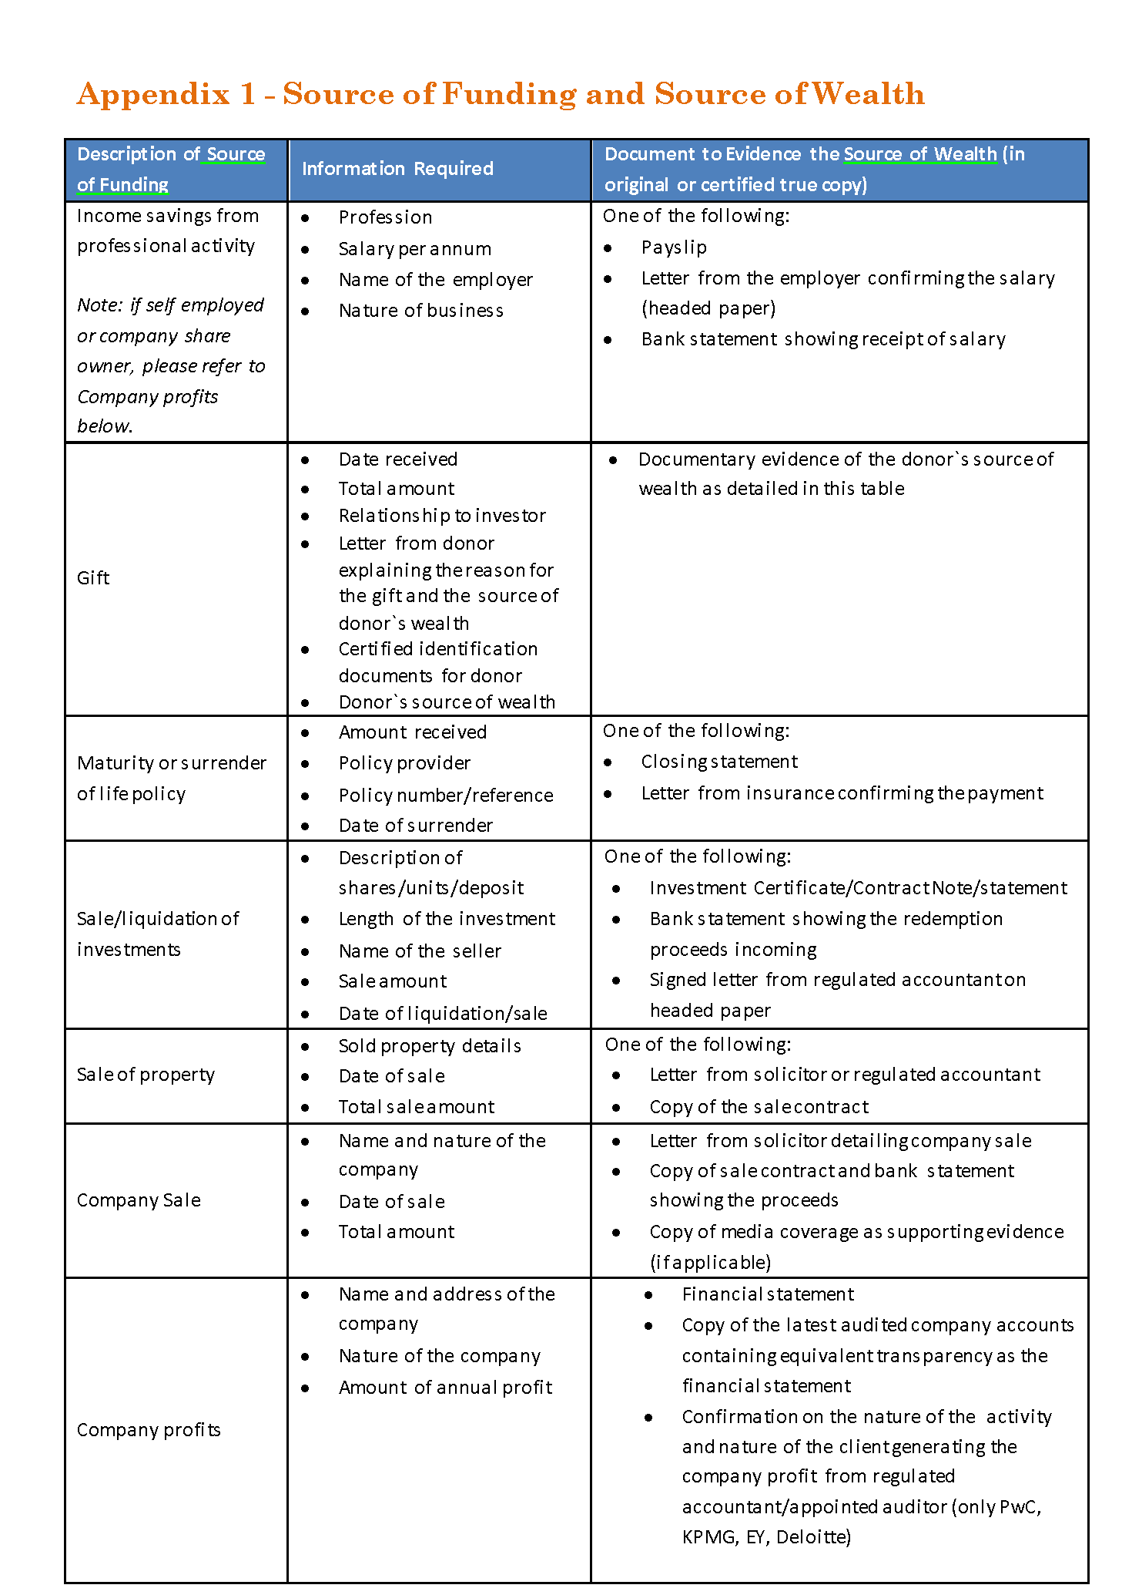

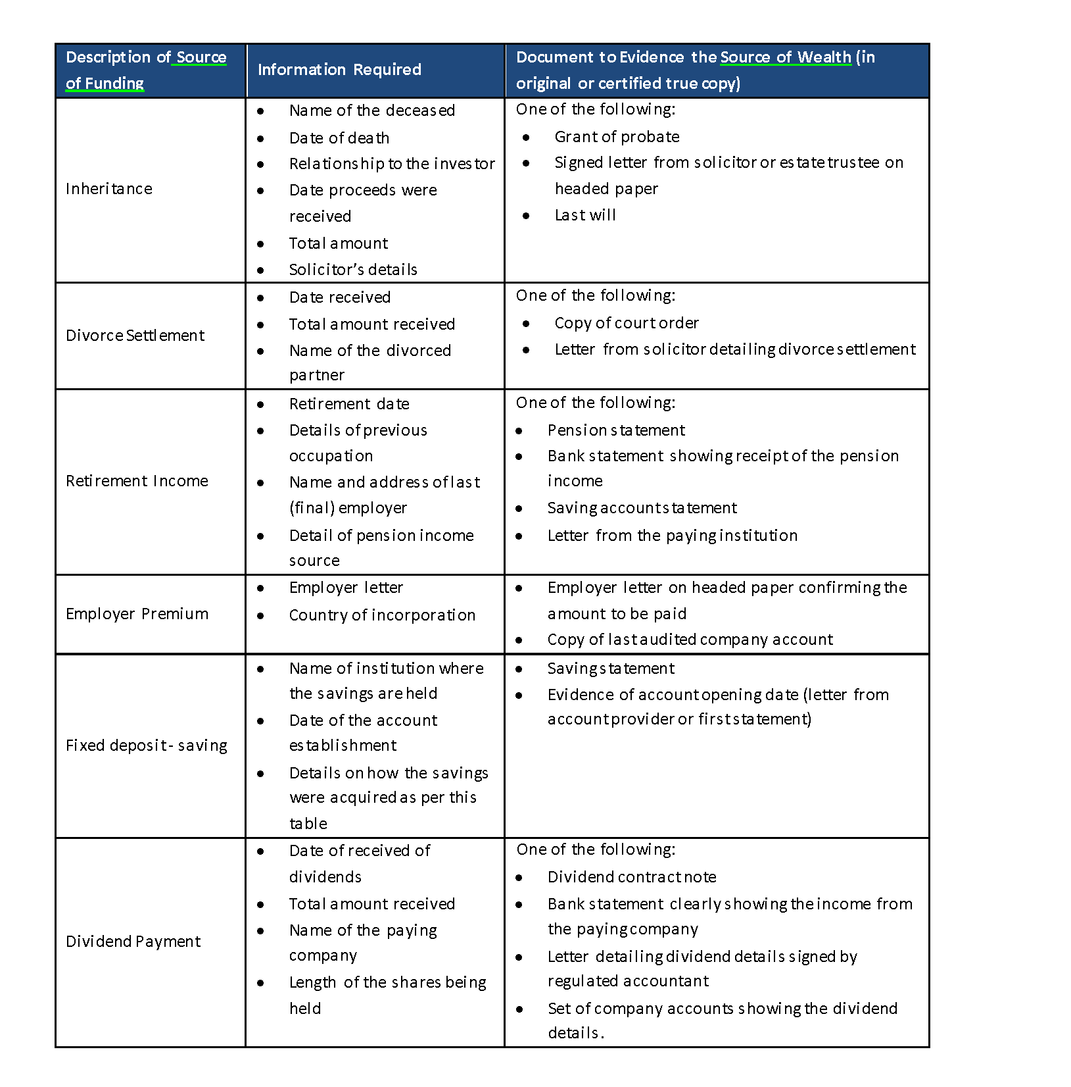

Please consider documentary evidence to support both your source of funds and independently source of wealth. See explanation provided on page 1.

